Quantum Clustering Algorithms

1. Problem
Clustering is an unsupervised learning task that groups data points based on similarity. Classical clustering algorithms such as k-means, hierarchical clustering, and density-based clustering require repeated distance computations, which become costly for large, high-dimensional datasets.
Quantum clustering algorithms aim to leverage quantum subroutines—such as quantum distance estimation, quantum linear algebra, and quantum state overlap—to accelerate similarity computation and clustering decisions.

2. Intuition
The intuition behind quantum clustering is:
- Encode data points into quantum states
- Use quantum circuits to compute similarities or distances efficiently
- Assign data points to clusters based on quantum-evaluated similarity
Quantum mechanics enables parallel evaluation of high-dimensional inner products, which is the bottleneck of many clustering methods.

3. Algorithm / Circuit Structure
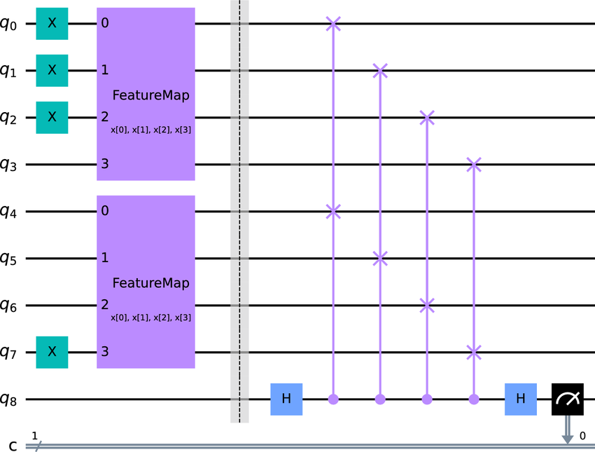
A typical quantum clustering workflow consists of:
- Data Encoding
Classical vectors are encoded into quantum states (amplitude or angle encoding).
- Distance / Similarity Estimation
Quantum circuits (e.g., swap test or inner-product estimation) compute pairwise distances.
- Cluster Assignment
Classical logic assigns each data point to the nearest cluster centroid.
- Centroid Update (Hybrid)
Cluster centroids are updated classically.
This results in a hybrid quantum–classical clustering algorithm.

4. Simple Math Involved
- Inner product: [ x | c_j ]
- Euclidean distance: [ |x - c_j|^2 = 2 - 2x | c_j ]
- Cluster assignment: [ (x) = _j |x - c_j| ]

5. Python Code (Quantum Clustering – Qiskit)
import numpy as np
from qiskit import QuantumCircuit
from qiskit.primitives import Sampler
def normalize(v):
return v / np.linalg.norm(v)
X = [
normalize(np.array([1.0, 0.2])),
normalize(np.array([0.9, 0.1])),
normalize(np.array([0.1, 0.9])),
normalize(np.array([0.2, 1.0]))
]
centroids = [
normalize(np.array([1.0, 0.0])),
normalize(np.array([0.0, 1.0]))
]
def quantum_distance(vec1, vec2, shots=512):
qc = QuantumCircuit(3)
qc.h(0)
qc.initialize(vec1, 1)
qc.initialize(vec2, 2)
qc.cswap(0, 1, 2)
qc.h(0)
qc.measure_all()
sampler = Sampler()
result = sampler.run(qc, shots=shots).result()
p0 = result.quasi_dists[0].get("000", 0)
overlap = 2 * p0 - 1
return np.sqrt(2 - 2 * overlap)
clusters = {0: [], 1: []}
for x in X:
distances = [quantum_distance(x, c) for c in centroids]
cluster_id = np.argmin(distances)
clusters[cluster_id].append(x)
print("Cluster assignments:")
for k, v in clusters.items():
print(f"Cluster {k}: {len(v)} points")

6. Where the Algorithm Is Useful
- Unsupervised learning
- High-dimensional data clustering
- Pattern discovery
- Quantum-enhanced similarity analysis

7. Limitations
- Requires efficient quantum data encoding
- QRAM assumptions are strong
- Noise affects distance accuracy
- No current practical quantum advantage

8. Comparison with Classical Clustering
- Distance computation: Quantum may scale better in high dimensions
- Centroid update: Classical in both approaches
- Maturity: Classical clustering is mature; quantum clustering is experimental
- Output: Both return classical cluster labels

9. One-Sentence Summary
Quantum clustering algorithms use quantum distance estimation to group data points more efficiently in high-dimensional spaces.

